1. **Convention 1 :** The origin is placed in the center of mass to allow for accurate and proper scaling and rotation

**Convention 2 :** Faces are described in the same direction (typically counter clockwise) in order to allow for back face culling

|  |  |  |  |
| --- | --- | --- | --- |
| **0** | -1 | -1 | 1 |
| **1** | 1 | -1 | 1 |
| **2** | 1 | 1 | 1 |
| **3** | -1 | 1 | 1 |
| **4** | -1 | -1 | -1 |
| **5** | 1 | -1 | -1 |
| **6** | 1 | 1 | -1 |
| **7** | -1 | 1 | -1 |

|  |  |  |  |
| --- | --- | --- | --- |
| **0** | 0 | 1 | 2 |
| **1** | 0 | 2 | 3 |
| **2** | 1 | 5 | 6 |
| **3** | 1 | 6 | 2 |
| **4** | 4 | 7 | 6 |
| **5** | 4 | 6 | 5 |
| **6** | 0 | 3 | 7 |
| **7** | 0 | 7 | 4 |
| **8** | 2 | 6 | 7 |
| **9** | 2 | 7 | 3 |
| **10** | 0 | 4 | 5 |
| **11** | 0 | 5 | 1 |

1. **Vertex List Index List**

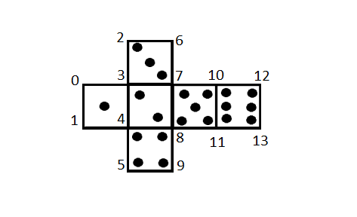

1. Texturing is the process of assigning an image to the surface of a model by means of mapping triangles of the texture image to faces of the model

|  |  |  |
| --- | --- | --- |
| **0** | 0 | 0.666… |
| **1** | 0 | 0.333… |
| **2** | 0.25 | 1 |
| **3** | 0.25 | 0.666… |
| **4** | 0.25 | 0.333… |
| **5** | 0.25 | 0 |
| **6** | 0.5 | 1 |
| **7** | 0.5 | 0.666… |
| **8** | 0.5 | 0.333… |
| **9** | 0.5 | 0 |
| **10** | 0.75 | 0.666… |
| **11** | 0.75 | 0.333… |
| **12** | 1 | 0.666… |
| **13** | 1 | 0.333… |

1. **Texture Co-ordinates List**